**Title: Design Methodology and Sources**

**Name: Jolene Branch**

**Course: DSC640**

**Date: January 6, 2021**

**Description: Justification/Defense of chosen design methodology, plus sources**

**Design methodology (and associated Gestalt Principles):**

-used Power BI because I can use what I learn at work, where we do not have Tableau

-six charts because that was the assignment minimum

-started out with all charts using shades of blue. Changed automotive data to yellow to follow the Gestalt Principle of Similarity. That drew too much attention to it, so I changed the airline fatality rate line to red. Changed columns on the upper right chart to red for balance. (See images below).

-removed borders from three charts, as adjacent charts’ borders still provide for the Gestalt Principle of Enclosure/Common Region. Doing so also made it less obvious that the two charts on the right are different heights than the others, which violated the Principle of Continuation.

-title is in upper left because that is where we generally look to first. Main point of the chart is immediately below that, with key words in the message BOLDED to draw attention.

-where I could, sources are in lighter shade of gray, to NOT draw attention to their text

-removed x-axis values on bottom right bar chart to keep viewers’ eyes up on the bars themselves. I could not seem to make it work with the bottom left bar chart, though.

-I do not like the step chart of cumulative airline deaths, but I needed another type of chart besides line charts and bar/column charts and did not know what other data to use in a column chart for this dashboard.

References:

<https://www.ntsb.gov/investigations/data/Pages/Data_Stats.aspx>

<https://injuryfacts.nsc.org/all-injuries/historical-preventable-fatality-trends/standardized-rate/>

<https://injuryfacts.nsc.org/motor-vehicle/historical-fatality-trends/deaths-and-rates/>

<https://github.com/fivethirtyeight/data/tree/master/airline-safety>

<https://www.census.gov/data/tables/2018/econ/services/sas-naics.html>

<https://aviation-safety-net./database>

<https://data.world/hhaveliw/airplane-crashes-1908-2009>

<https://www.nhtsa.gov/content/nhtsa-ftp/280561>

With borders around all charts:

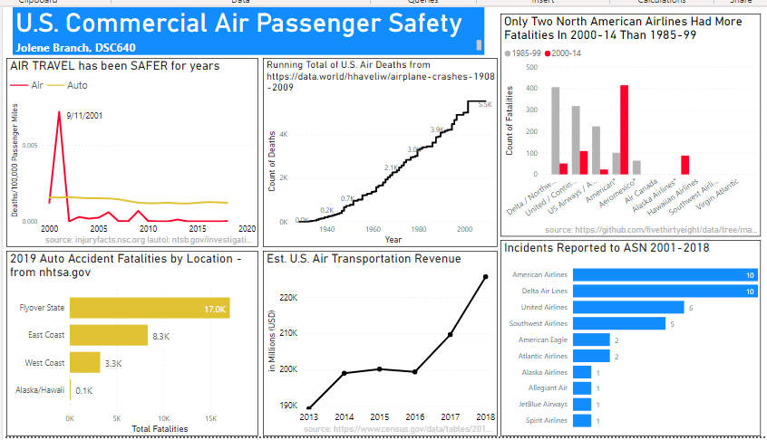

After removing borders from three charts:

